|  |  |  |  |  |  |  |  |  |
| --- | --- | --- | --- | --- | --- | --- | --- | --- |
| Forecast Values | |  |  |  | Compiler Engine Information | | |  |
|  |  |  |  |  |  |  |  |  |
| Stand ID: | | 1841096 |  |  | GYPSY Model: | | 2009-May-21 | |
| Stand Type: | | Natural |  |  | Application: | | 20100713p |  |
| Stand Age: | | 118 | years |  | COM DLL: | | 20100329b35 | |
| Spatial: | | NO |  |  |  |  |  |  |
| BA adjusted: | | YES |  |  |  |  |  |  |
|  |  |  |  |  |  |  |  |  |
| Input Data | |  |  |  |  |  |  |  |
|  |  |  |  |  |  |  |  |  |
| Species | | totage | topht | den | ps | ba | utilization |  |
| AW |  | 118.0 | 19.44 | 114 |  | 5.25 | 13/7/30 |  |
| SB |  |  |  |  |  |  | 15/10/30 |  |
| SW |  | 83.0 | 19.44 | 97 |  | 4.45 | 13/7/30 |  |
| PL |  | 99.0 | 19.44 | 671 |  | 30.74 | 13/7/30 |  |
|  |  |  |  |  |  |  |  |  |
| Calculated Attributes | | |  |  |  |  |  |  |
|  |  |  |  |  |  |  |  |  |
| Species | | bhage | y2bh | si_bh | si_t | n0 | sdf | psi |
| AW |  | 112.5 | 5.5 | 12.2 | 11.3 | 133 | 131 |  |
| SB |  |  |  |  |  |  |  |  |
| SW |  | 73.7 | 9.3 | 14.8 | 12.7 | 98 | 97 |  |
| PL |  | 90.9 | 8.1 | 14.5 | 13.0 | 2,243 | 1,475 |  |

Tesera Gypsy

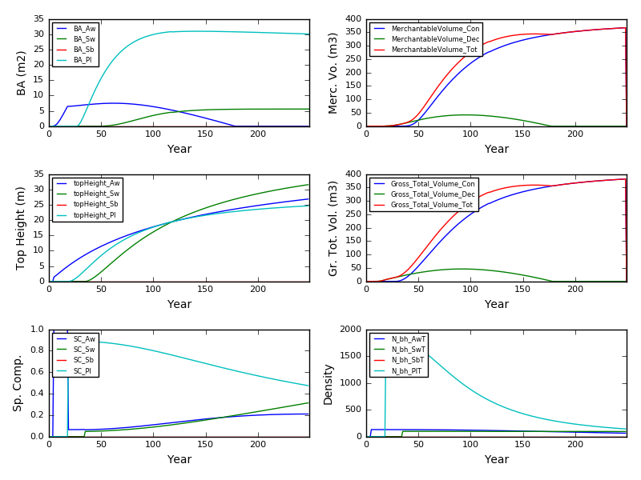

Excel Gypsy

